SQL Assignments (02)

EMP Table Structure:

Name Null? Type

EMPNO NOT NULL NUMBER(4), Primary Key ENAME VARCHAR2(10)
JOB VARCHAR2(9)
MGR NUMBER(4)
HIREDATE DATE
SAL NUMBER(7,2)
COMM NUMBER(7,2)
DEPTNO NUMBER(2) foreign key of DEPT table Records in EMP Table
EMPNO ENAME JOB MGR HIREDATE SAL COMM DEPTNO

7369 SMITH | CLERK | 7902 17-DEC-80 | 800 |  |  | 20
7499 ALLEN | SALESMAN | 7698 20-FEB-81 | 1600 | 300 |  | 30
7521 WARD | SALESMAN | 7698 22-FEB-81 | 1250 | 500 |  | 30
7566 JONES | MANAGER | 7839 02-APR-81 | 2975 |  |  | 20
7654 MARTIN | SALESMAN | 7698 28-SEP-81 | 1250 | 1400 |  | 30
7698 BLAKE | MANAGER | 7839 01-MAY-81 | 2850 |  |  | 30
7782 CLARK | MANAGER | 7839 09-JUN-81 | 2450 |  |  | 10
7788 SCOTT | ANALYST | 7566 19-APR-87 | 3000 |  |  | 20
7839 KING | PRESIDENT | 17-NOV-81 | 5000 |  |  | 10
7844 TURNER | SALESMAN | 7698 08-SEP-81 | 1500 | 0 |  | 30
7876 ADAMS | CLERK | 7788 23-MAY-87 | 1100 |  |  | 20
7900 JAMES | CLERK | 7698 03-DEC-81 | 950 |  |  | 30
7902 FORD | ANALYST | 7566 03-DEC-81 | 3000 |  |  | 20
7934 MILLER | CLERK | 7782 23-JAN-82 | 1300 |  |  | 10

DEPT Table Structure:

Name Null? Type

DEPTNO NOT NULL NUMBER(2), Primary key DNAME VARCHAR2(14)
LOC VARCHAR2(13)

Records in DEPT Table:

DEPTNO DNAME LOC

10 |  | ACCOUNTING | NEW YORK
20 |  | RESEARCH | DALLAS
30 |  | SALES | CHICAGO
40 |  | OPERATIONS | BOSTON

Assignment # 02

- Display the name, deptno, dname for all employees.
- Create a unique listing of all jobs that are in deptno 30. Include the location of dept 30 in the output.
- Display the employee name, dept name and the location of all employees who earn a commission.
- Display the employee name, dept name for all employees who have an ‘A’ in their name.
- Display the employee name, job, deptno, dept name for all employees who work in DALLAS.
- Display the employee name of all the employees that work in the same deptno as a given employee.
- Display the employee name, job, dept name, salary and grade for all employees.
- Display the employee name, and hire date of any employee hired after BLAKE.
- Find the second highest salary from emp table.

ANSWER

TO CREATE EMP AND DEPT TABLE

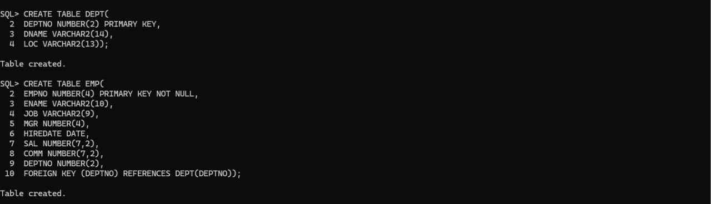

TO INSERT THE DATA IN DEPT TABLE

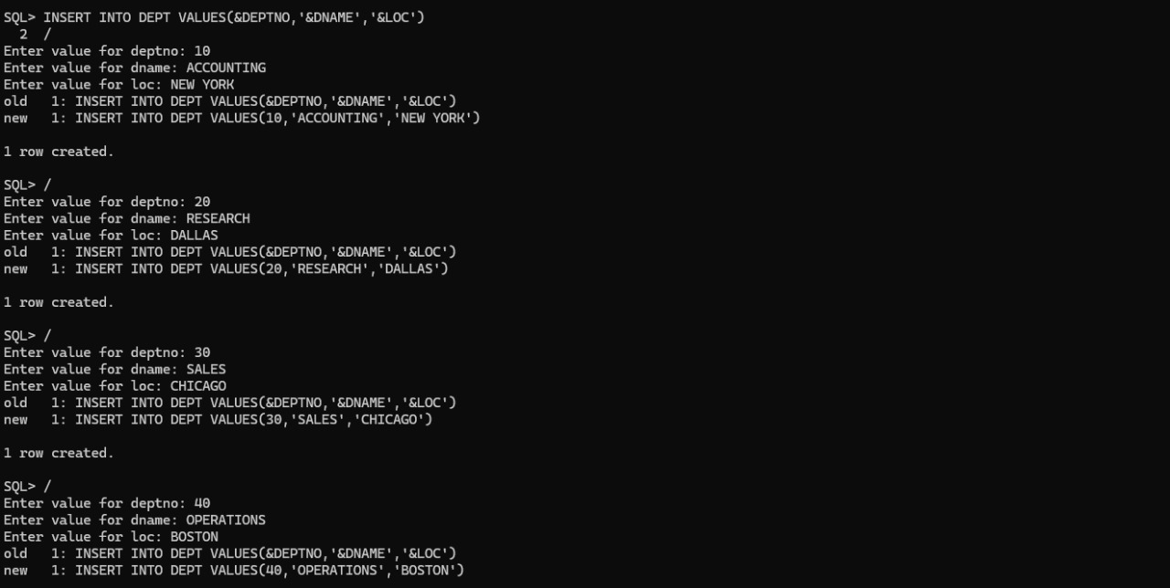

TO INSERT THE DATA IN EMP TABLE

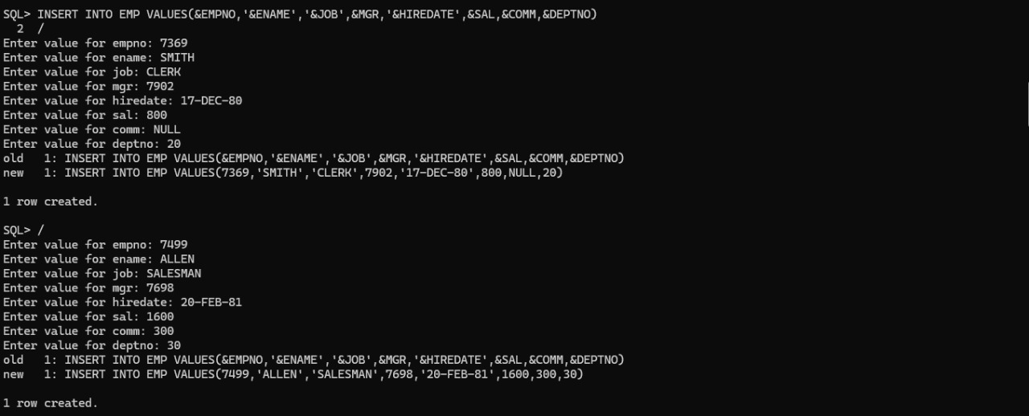

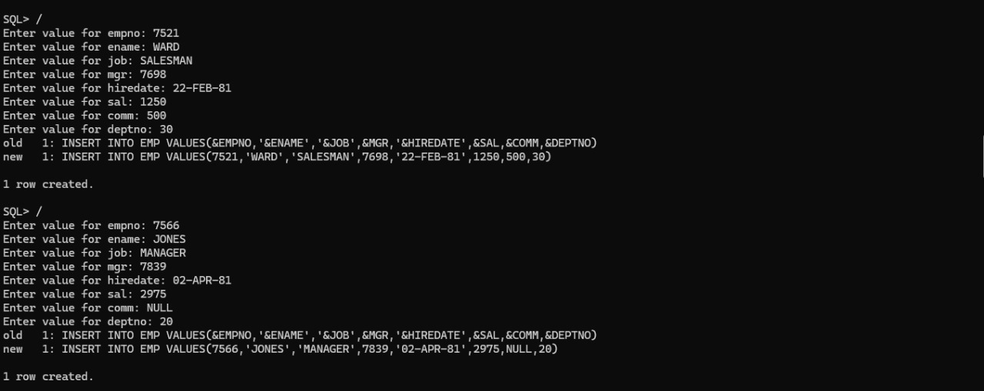

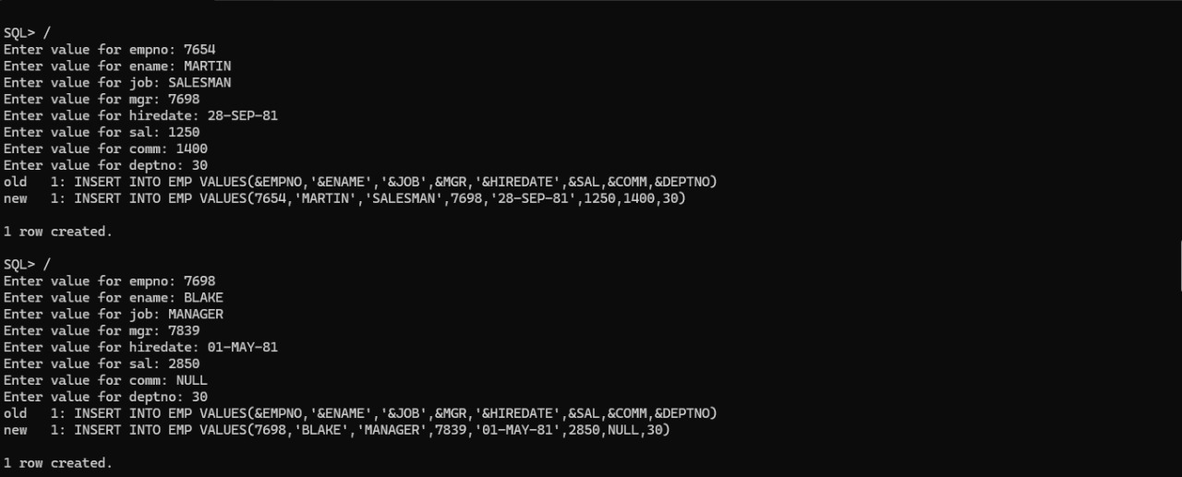

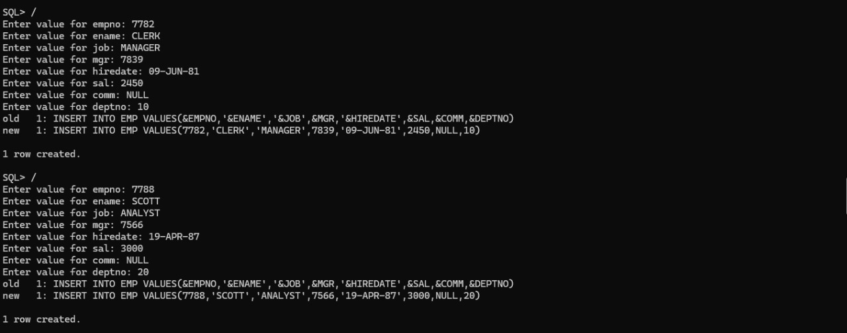

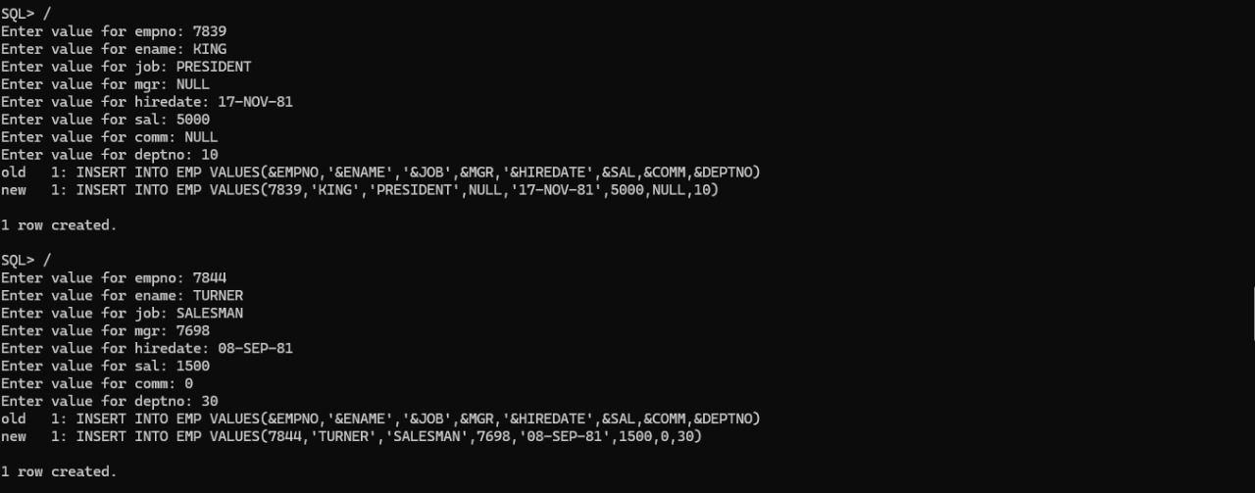

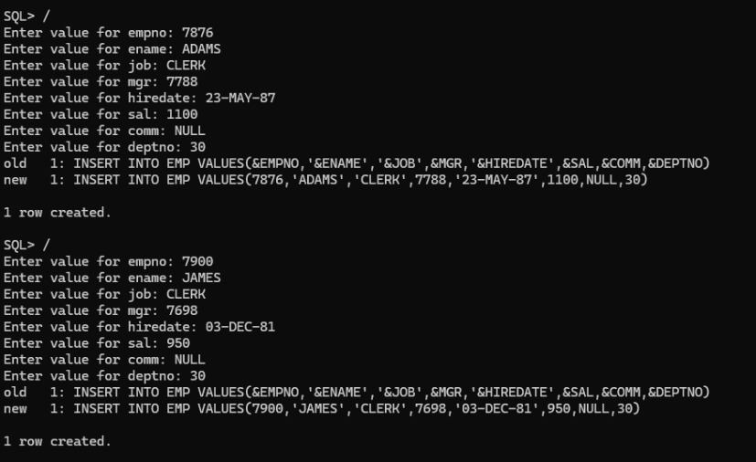

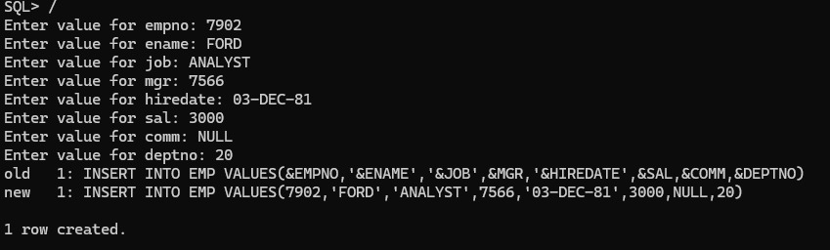

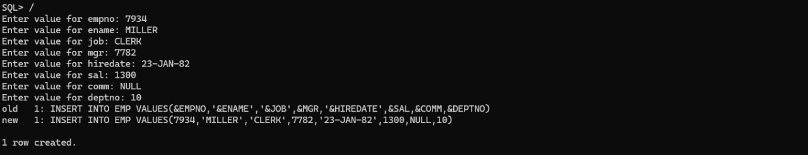

TO SHOW ALL THE DATA IN EMP TABLE

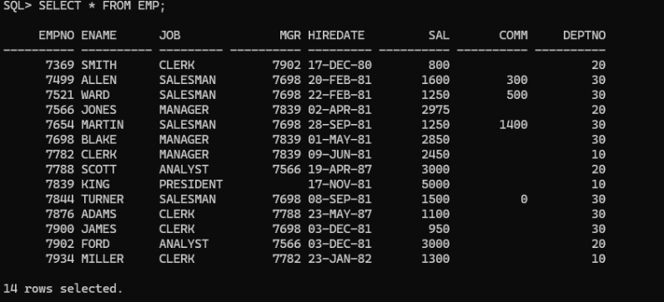

TO SHOW THE DATA IN DEPT TABLE

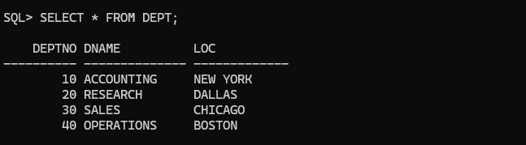

Display the name, deptno, dname for all employees.

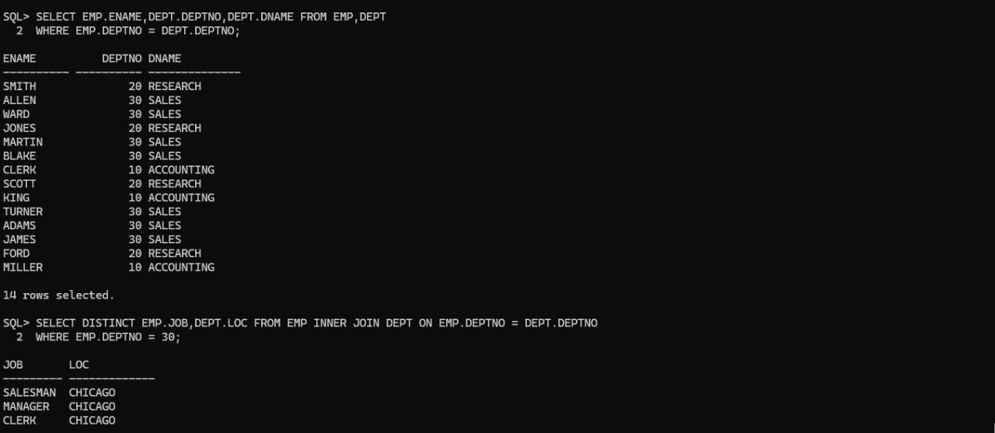

Create a unique listing of all jobs that are in deptno 30. Include the location of dept 30 in the output.

Display the employee name, dept name and the location of all employees who earn a commission.

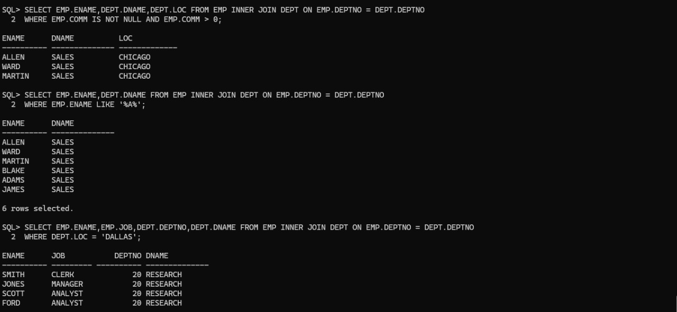

Display the employee name, dept name for all employees who have an ‘A’ in their name.

Display the employee name, job, deptno, dept name for all employees who work in DALLAS.

Display the employee name of all the employees that work in the same deptno as a given employee.

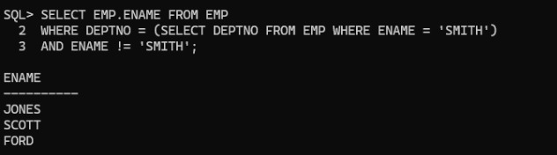

Display the employee name, job, dept name, salary and grade for all employees.

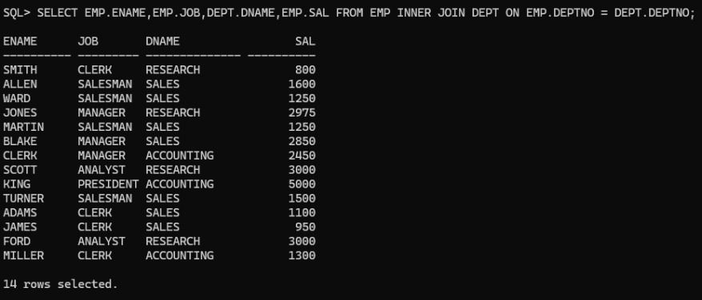

Display the employee name, and hire date of any employee hired after BLAKE.

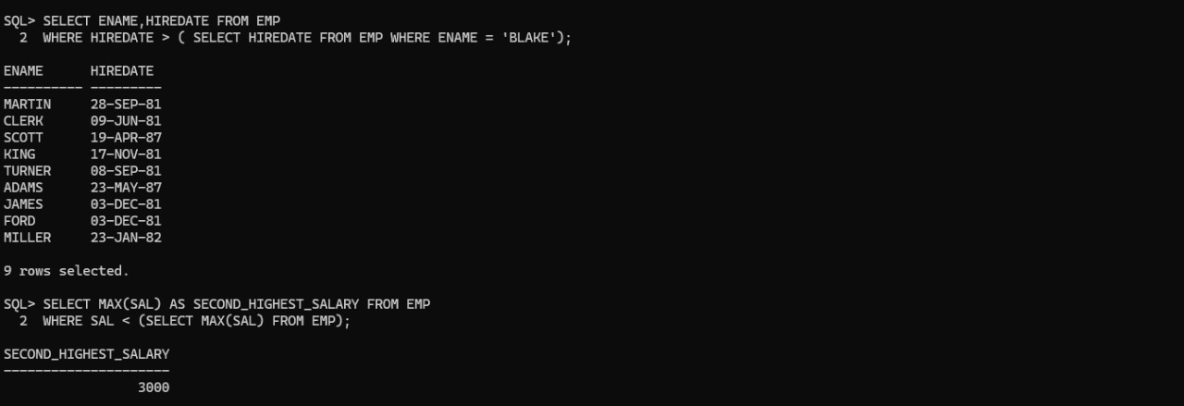

Find the second highest salary from EMP table.

